Module 1: Assignment 1
Name
Institution
Date

Module 1: Assignment 1
Introduction
A collaborative consultation teacher should learn the skills of understanding their inner self as well as interacting with others. This paper provided a test that allows the participants to reflect express their cultural identities. The IAT test to be discussed includes race disability and thin-fat in addition to a personal reflection related to the results produced.
Result’s explanations
The results relating to race reveals that I have a moderate automatic preference for whites over blacks. I must say that the results depict my personality towards individuals originating from African and European because I tend to be slightly warm towards Europeans compared to Africans. On its part, the disability results confirm that I prefer interacting more with able as compared to disabled concerning the answers I provided during the identification of signs. Besides, the weight IAT enlightens that I tend to be moderately warm towards thin persons, which is opposite to what I provided during the test. Precisely, I recoded to be moderately cold towards t n individuals.

Disability IAT Test Results.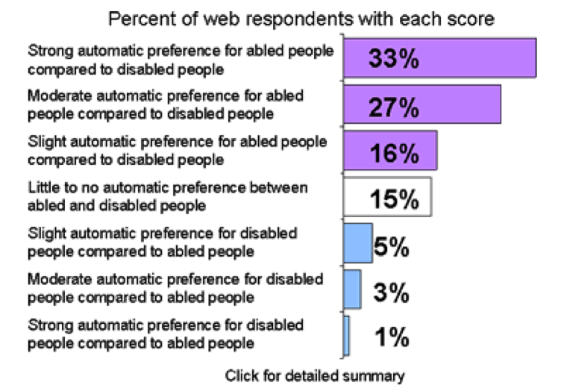
Race IAT Test Scores.
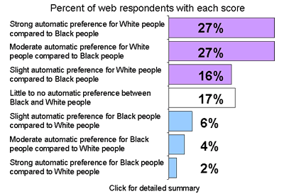

Weight IAT Test Scores.
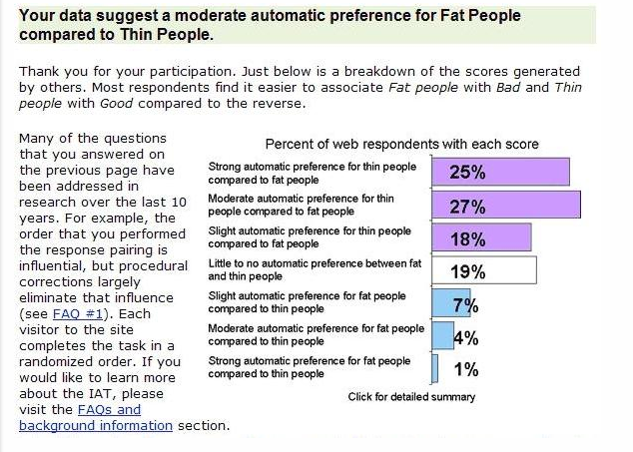
Views towards the results
I fully concur with the results relating to race that I tend to prefer white individuals as opposed to blacks moderately. Equally, I always believe that whites are more favorable compared to blacks. Again, I'm afraid I have to disagree with disability IAT results because they are far much different from what I provided during the test. In the experiment, I showed equal interest in both the able and the disabled. Again, the generated results regarding thin and fat people contradict with my beliefs. During the test, I showed much interest to fat individuals. However, the results describe my personality as a person who prefers thin persons over the fat.
What I learned about myself
The various test has enabled me to give thought out and honest answers regarding personal identity. Again, the provided series of questions contributed hugely in asking myself multiple questions related to my own beliefs. Notably, it is through undergoing the test that I have learned to listen to my inner voice and being real to people battling with adverse conditions. Importantly, I have come to learn more about my body parts after I completed the three tests; for instance, I have realized why I prefer interacting with moderately thin individuals.
Cultural identity impacts to collaborative consultants
The application of cultural identity and beliefs by the collaborative consultant will be much helpful in boosting the wellbeing of the victims. Von Ahlefeld (2017) opines that the students feel the sense of belonging as well as security once the consultants have identified themselves with a particular culture. Importantly, it is through utilizing the propositions of cultural identity that the consultants will have access to diverse social networks. Notably, the cultural beliefs acquired by the consultants will be imparted to the students, which will, in turn, boost the unity among the two groups.
Cultural identity challenges
Notably, cultural identities have a diverse origin as well as languages. As a result, individuals sharing similar cultural identities will tend to use the same language, which is entirely different from others, thereby bringing in the language barrier (Warren, 2017). Another challenge posed by cultural identity is social tension, which comes as a result of linguistic differences. Social anxiety occurs when some students and consultant's beliefs differ with those of their peers. Von Ahlefeld (2017) enlightens that the issue of integrating social identity in the operations of the workplace has brought various alarming concerns. Precisely, several employees feel discriminated after being introduced to the diverse cultural characters of other employees.
What can be changed in self-identity?
Overly, I can change my cultural identity by learning the significance of self-efficiency, which leads to self-valuation. Notably, it through self- honoring that individuals begin to respect their cultural beliefs. Again, improving intercultural competency is vital for one in realizing the provisions of another person's cultural beliefs. Mastering diverse cultural identities equip one in dealing with distinct personalities hence minimizing instances of social unrest. It worth noting that practicing empathy as well valuing others contributes significantly to upholding cultural identities. As a result, individuals should respect, honor rights, and beliefs of diverse cultural origins as well as personalities.
Conclusion
Overly, IAT tests are vital for collaborative teachers to learn more about their culture and personal identities. The analysis provides an opportunity for examining one's perception of human being's aspects, including age, race, body size, and gender. It is, however, worth noting that some results generated from the test do not reflect the precise identity of a person.

References
von Ahlefeld Nisser, D. (2017). Can collaborative consultation, based on communicative theory,
promote an inclusive school culture?. Issues in educational research, 27(4), 874.
Warren, J. M. (2017). School Consultation for Student Success: A Cognitive-behavioral
Approach. Springer Publishing Company.

